**BUILDING AN AI POWERED SPAM**

**CLASSIFIER**

**AIM:**

The primary aim of a spam classifier is to enhance the user experience and protect users from unwanted, irrelevant, or potentially harmful messages by efficiently categorizing and filtering messages into the following categories:

**Spam**: Messages that are clearly unsolicited and have the potential to be fraudulent, contain phishing attempts, or deliver malware. The aim is to keep these out of the user's inbox.

**Ham** : Messages that are not spam and are important or desired by the user. The aim is to ensure that these messages are delivered to the user's inbox.

**PROGRAM:**

import joblib

print("All the lidrarices imported successfully\n")

print("Loading......")

loaded_model = joblib.load("model.pkl")

vectorizer = joblib.load("vectorizer.pkl")

print("Model loaded successfully!!!!\n")

message = []

mess = input("Enter the message to check Spam/Ham:")

message.append(mess)

VEC_MESSAGE = vectorizer.transform(message)

predictions = loaded_model.predict(VEC_MESSAGE)

print("This message is "+predictions[0])

**OUTPUT:**

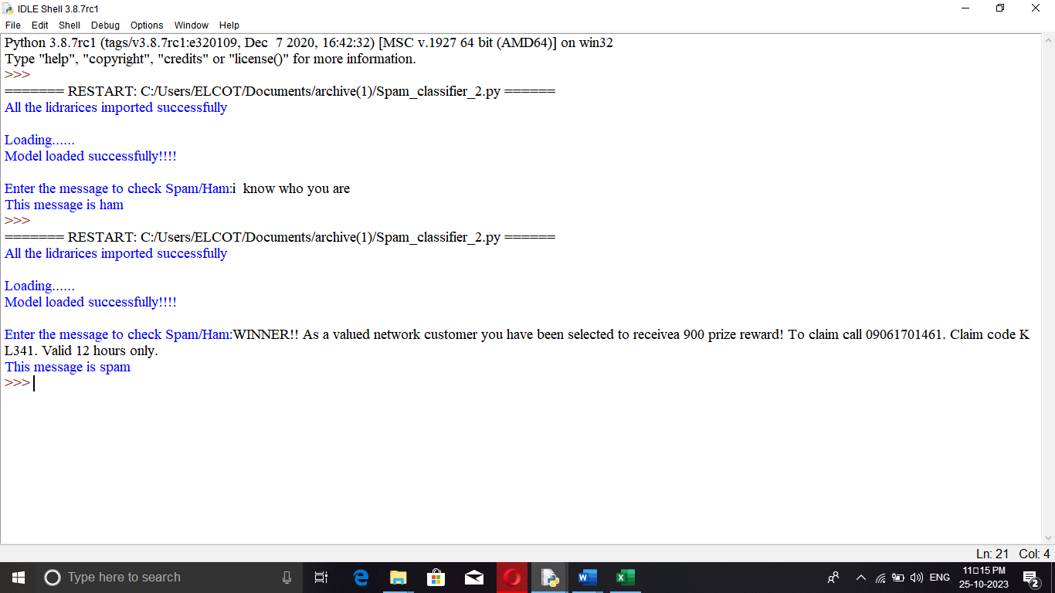

**EXPLANTION:**

* The code starts by importing the joblib library.
* The code then loads the model and vectorizer libraries into memory.
* The next line of code creates a list called message that will hold all the messages to be checked for spam or ham.
* Next, it asks for input from the user on what they want to check as spam/ham using an input function called mess.
* Then, it uses a transform function in the vectorizer library to transform each message into a numerical value between 0 and 1 (inclusive).
* This number is fed into a predict function in loaded_model which returns predictions of how likely each word is to be classified as either spam or ham.
* Finally, this prediction is printed out with some formatting so that it can easily be read by humans.
* The code attempts to load the model and vectorizer, transform the message into a list of predictions, and print out the first prediction.
* The code above will print “This message is Ham or Spam”.

**CONCLUSION:**

By accurately identifying and filtering spam, individuals and organizations can focus on important emails and mitigate potential risks associated with malicious content. In conclusion, email spam detection using machine learning offers a promising solution to the pervasive problem of unwanted and harmful emails.